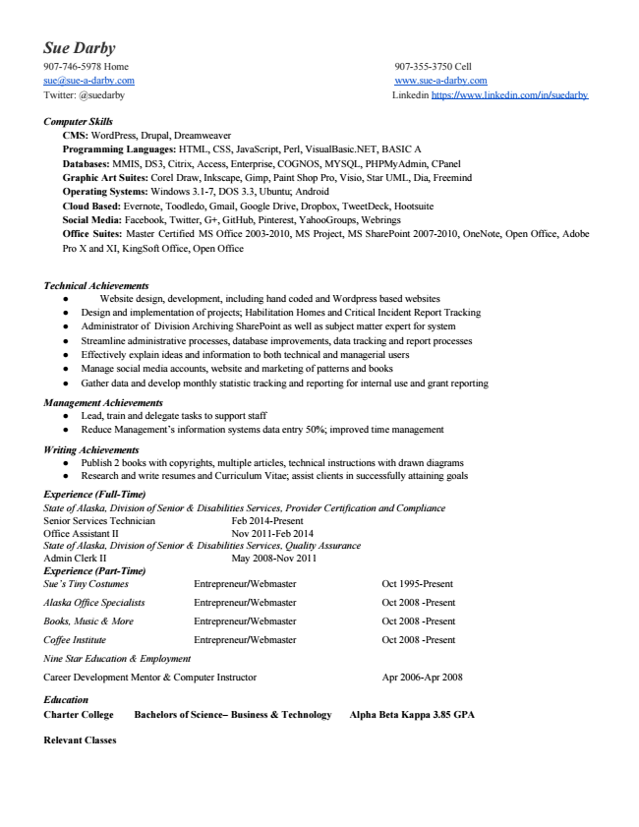

Sue Darby 907­746­5978 Home 907­355­3750 Cell sue@sue­a­darby.com ​www.sue­a­darby.com Twitter: @suedarby Linkedin ​https://www.linkedin.com/in/suedarby

***Computer Skills***

CMS:​ WordPress, Drupal, Dreamweaver Programming Languages:​ HTML, CSS, JavaScript, Perl, VisualBasic.NET, BASIC A Databases:​ MMIS, DS3, Citrix, Access, Enterprise, COGNOS, MYSQL, PHPMyAdmin, CPanel Graphic Art Suites:​ Corel Draw, Inkscape, Gimp, Paint Shop Pro, Visio, Star UML, Dia, Freemind Operating Systems:​ Windows 3.1­7, DOS 3.3, Ubuntu; Android Cloud Based:​ Evernote, Toodledo, Gmail, Google Drive, Dropbox, TweetDeck, Hootsuite Social Media:​ Facebook, Twitter, G+, GitHub, Pinterest, YahooGroups, Webrings Office Suites: Master Certified MS Office 2003­2010, MS Project, MS SharePoint 2007­2010, OneNote, Open Office, Adobe Pro X and XI, KingSoft Office, Open Office

***Technical Achievements***

● Website design, development, including hand coded and Wordpress based websites

● Design and implementation of projects; Habilitation Homes and Critical Incident Report Tracking

● Administrator of Division Archiving SharePoint as well as subject matter expert for system

● Streamline administrative processes, database improvements, data tracking and report processes

● Effectively explain ideas and information to both technical and managerial users

● Manage social media accounts, website and marketing of patterns and books

● Gather data and develop monthly statistic tracking and reporting for internal use and grant reporting

***Management Achievements***

● Lead, train and delegate tasks to support staff

● Reduce Management’s information systems data entry 50%; improved time management

***Writing Achievements***

● Publish 2 books with copyrights, multiple articles, technical instructions with drawn diagrams

● Research and write resumes and Curriculum Vitae; assist clients in successfully attaining goals

*Experience (Full­Time) State of Alaska, Division of Senior & Disabilities Services, Provider Certification and Compliance Senior Services Technician Feb 2014­Present Office Assistant II Nov 2011­Feb 2014 State of Alaska, Division of Senior & Disabilities Services, Quality Assurance Admin Clerk II May 2008­Nov 2011 Experience (Part­Time) Sue’s Tiny Costumes Entrepreneur/Webmaster Oct 1995­Present*

Alaska Office Specialists Entrepreneur/Webmaster Oct 2008 ­Present

Books, Music & More Entrepreneur/Webmaster Oct 2008 ­Present

Coffee Institute Entrepreneur/Webmaster Oct 2008 ­Present

*Nine Star Education & Employment*

Career Development Mentor & Computer Instructor Apr 2006­Apr 2008

**Education Charter College Bachelors of Science– Business & Technology Alpha Beta Kappa 3.85 GPA**

**Relevant Classes**

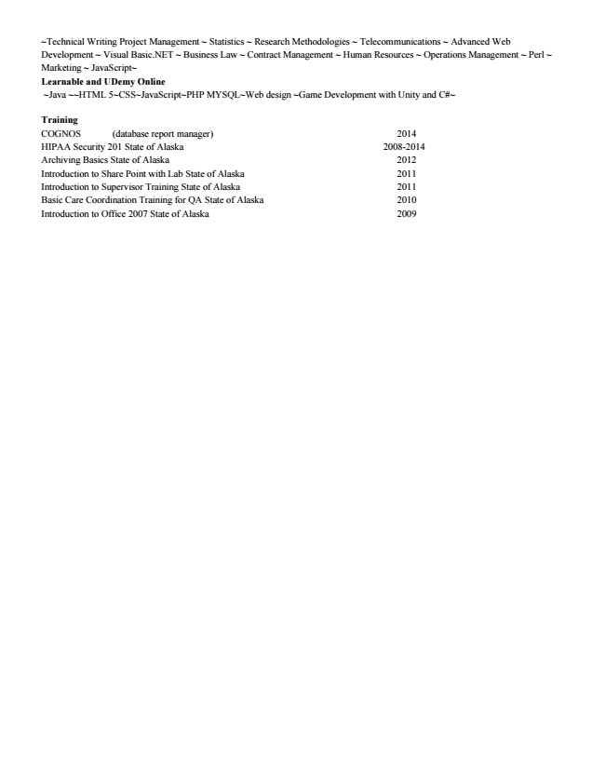

~Technical Writing Project Management ​~ Statistics ~ Research Methodologies ~ Telecommunications ~ Advanced Web Development ~ Visual Basic.NET ~ Business Law ~ Contract Management ~ Human Resources ~ Operations Management ~ Perl ~ Marketing ~ JavaScript~ Learnable and UDemy Online

~Java ~~HTML 5~CSS~JavaScript~PHP MYSQL~Web design ~Game Development with Unity and C#~

Training COGNOS (database report manager) 2014 HIPAA Security 201 State of Alaska 2008­2014 Archiving Basics State of Alaska 2012 Introduction to Share Point with Lab State of Alaska 2011 Introduction to Supervisor Training State of Alaska 2011 Basic Care Coordination Training for QA State of Alaska 2010 Introduction to Office 2007 State of Alaska 2009